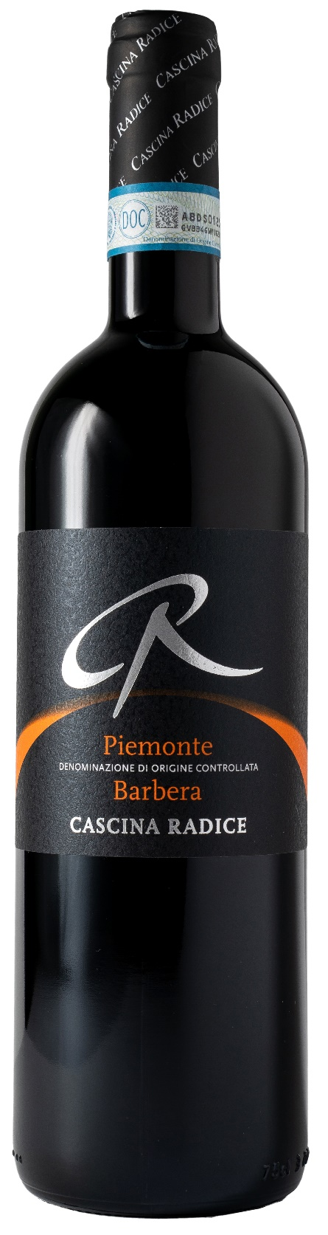
BARBERA PIEMONTE DOC – CR

Grape: Barbera 100%
Alc. Vol.%: 13
Vintage: 2024
Residual sugar g/l: 6,0
Total acidity g/l: 5,9
Region: Piedmont
Production zone: Vineyards in the Monferrato area
Capacity: 750ml

CHARACTERISTICS

Vinification: In steel tanks at a controlled temperature
Aging: 6 months in steel tanks
Yield per ha: 11000kg
Colour: Intensive red with purple reflections
Bouquet: Fruity and lasting with hints of spices
Flavour: Dry but smooth at the same time, full-bodied with noble tannins

SERVING SUGGESTIONS

Best with pasta, ripe cheese and grilled meat.
Serving temperature 16-18 °C
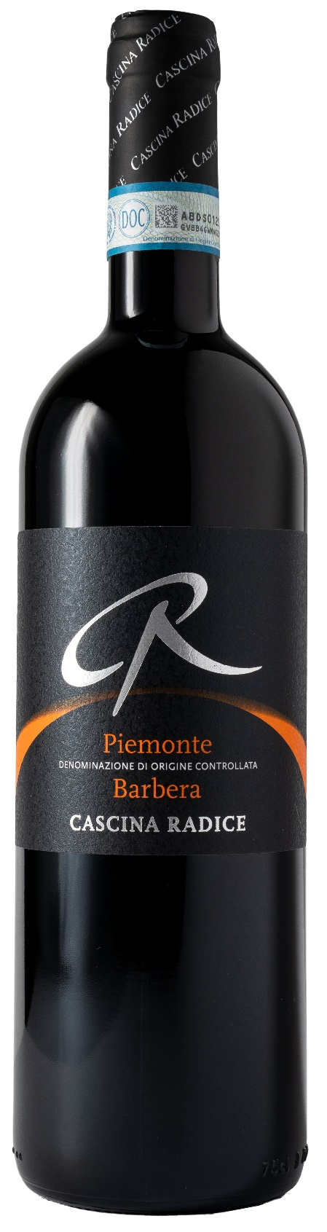
TECHNICAL INFORMATION / PALLETIZING

Size 750ml:
Article Nr. V02019A
GTIN-13 bottle 8017868003656
GTIN-13 carton 8017868003915
Closure Cork
Bottles / carton 6 bottles
Pallet size 80x120cm
Cartons/layer 24
Cartons/pallet 96
Kg/carton 7,8
Kg/pallet 780

Contains sulphites
GMO Free
Revisione 01. 21.04.2026

